**PRACTICAL NO.3**

**Exploring and Managing Raster data: Adding raster layers, raster styling and analysis, raster mosaicking and clipping**

**Adding raster layers:**

Layer > Add Layer > Add Raster Layer >

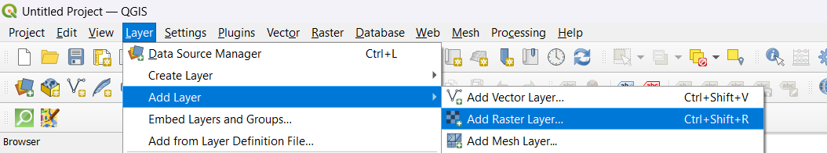

Select gl_gpwv3_pdens_00_ascii_one zip file > Open >

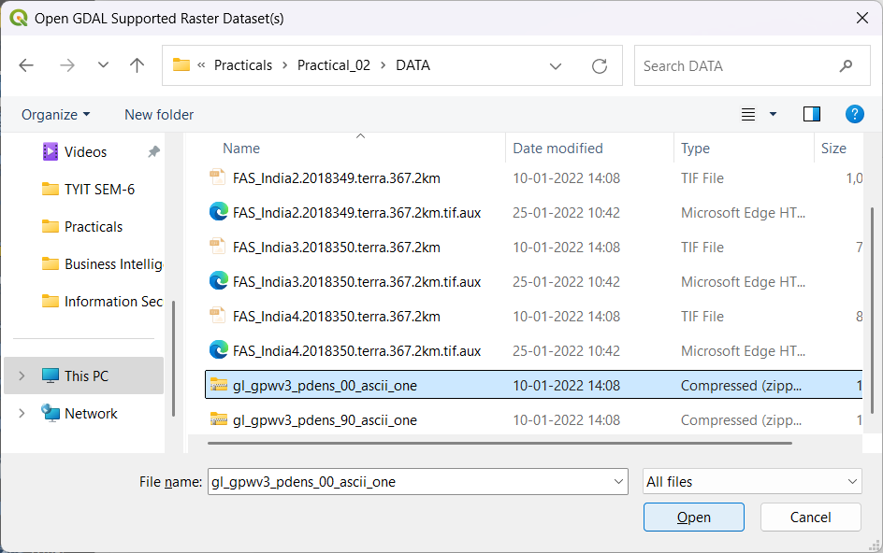

Click on Add >

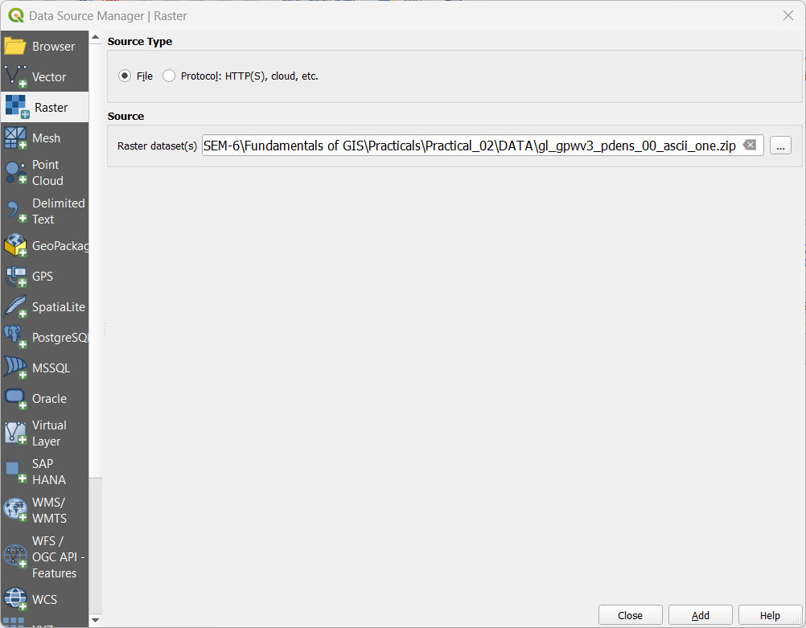

Select Items to Add > Select glds00g60.asc Item > Click Add Layers >

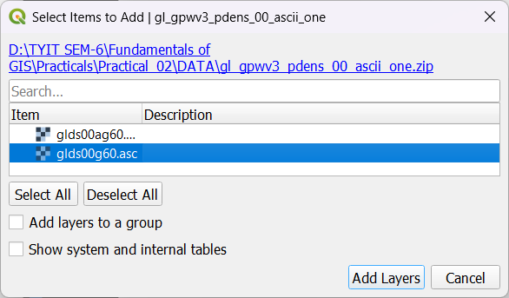

Output after adding Raster Layer : gl_gpwv3_pdens_00_ascii_one.zip >

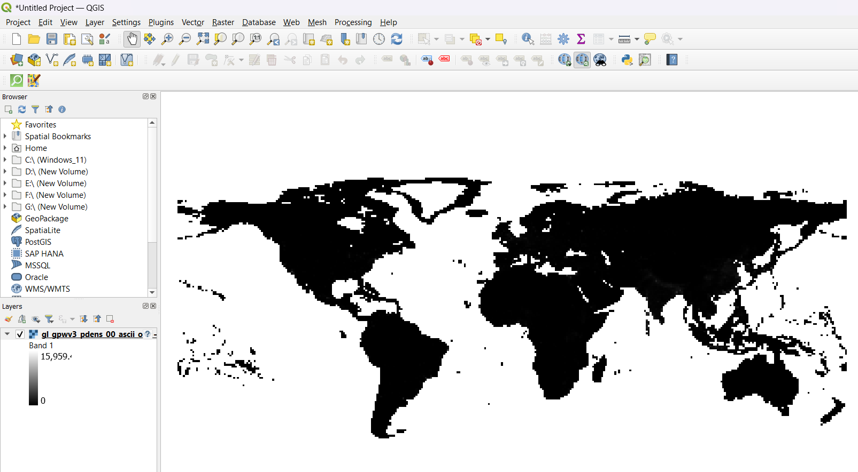

Layer > Add Layer > Add Raster Layer > Select gl_gpwv3_pdens_90_ascii_one zip file > Open >

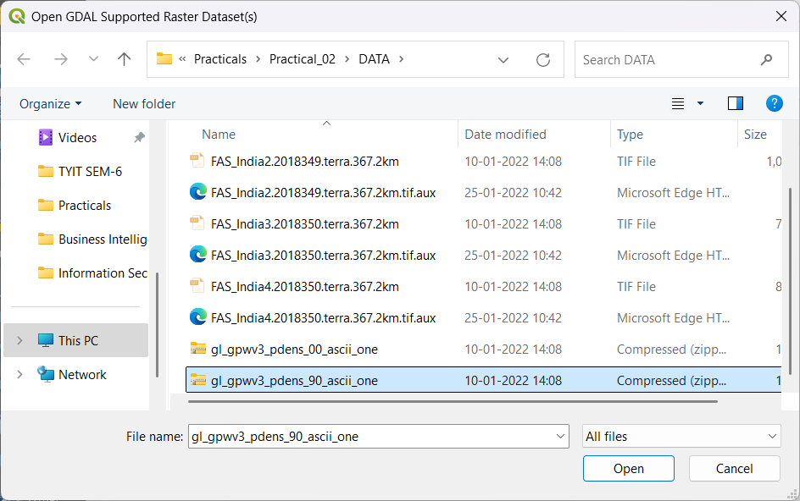

Click on Add >

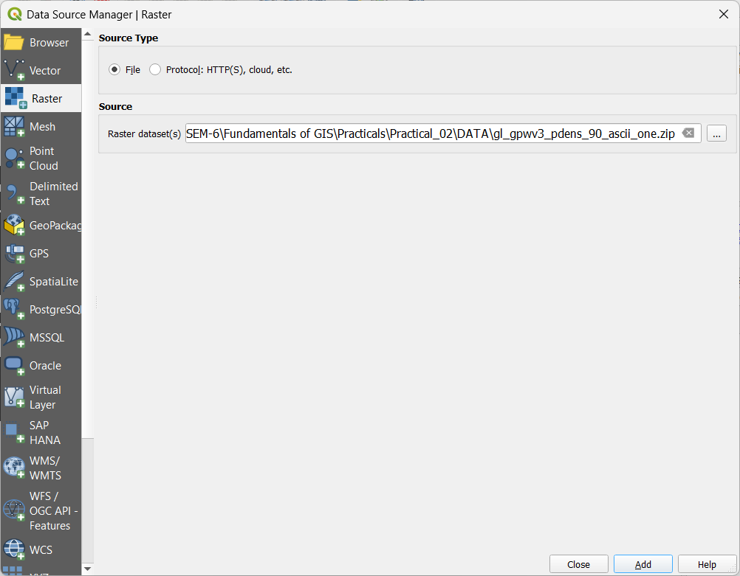

Select Items to Add > Select glds90g60.asc Item > Click Add Layers >

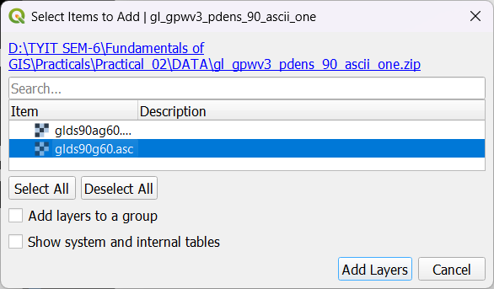

Output after adding Raster Layer : gl_gpwv3_pdens_90_ascii_one.zip >

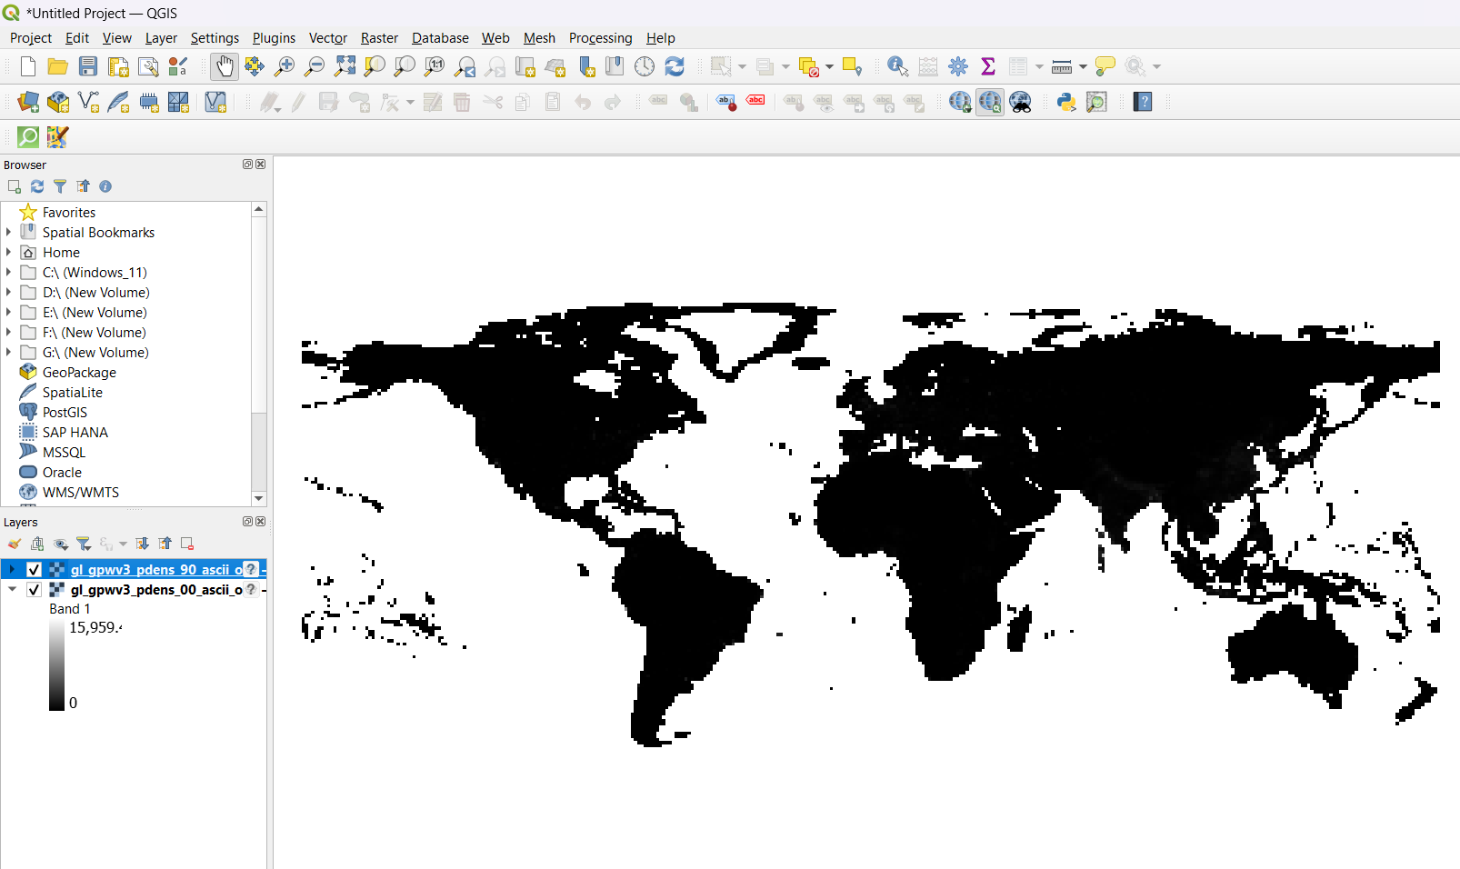

**Raster styling and analysis:**

Open Properties of gl_gpwv3_pdens_00_ascii_one Layer > Select render type as Singleband pseudocolor > Min : 0 and Max : 240 > select light color ramp > Apply >

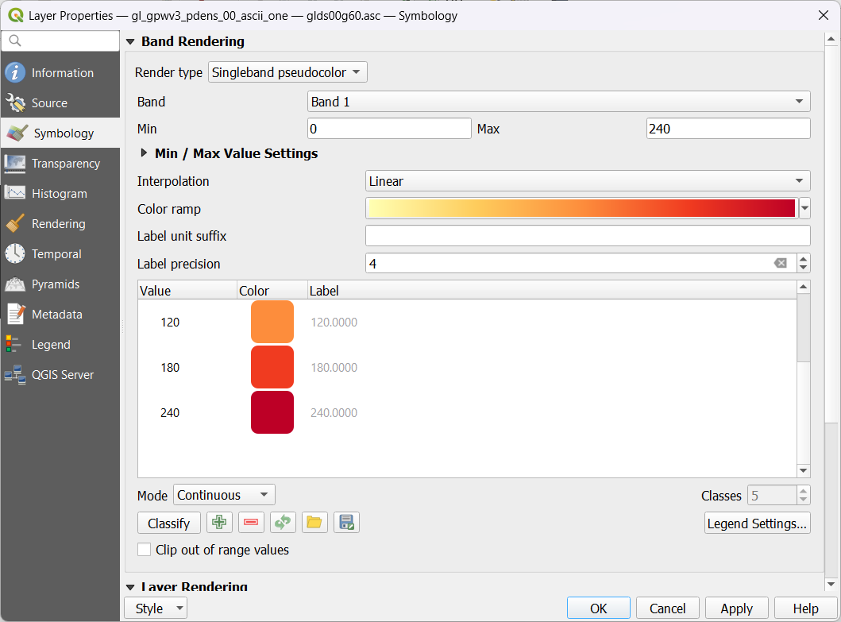

Output After Setting Properties to gl_gpwv3_pdens_00_ascii_one Layer >

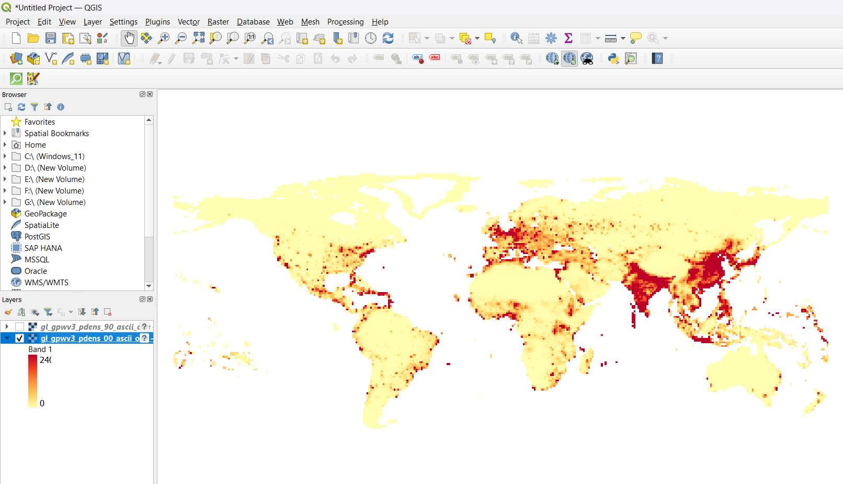

Open Properties of gl_gpwv3_pdens_90_ascii_one Layer > Select render type as Singleband pseudocolor > Min : 0 and Max : 240 > select light color ramp > Apply >

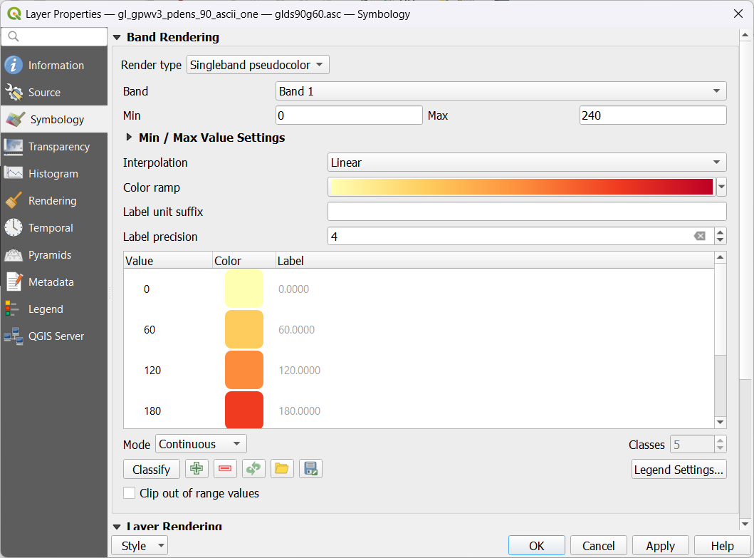

Output After Setting Properties to gl_gpwv3_pdens_90_ascii_one Layer >

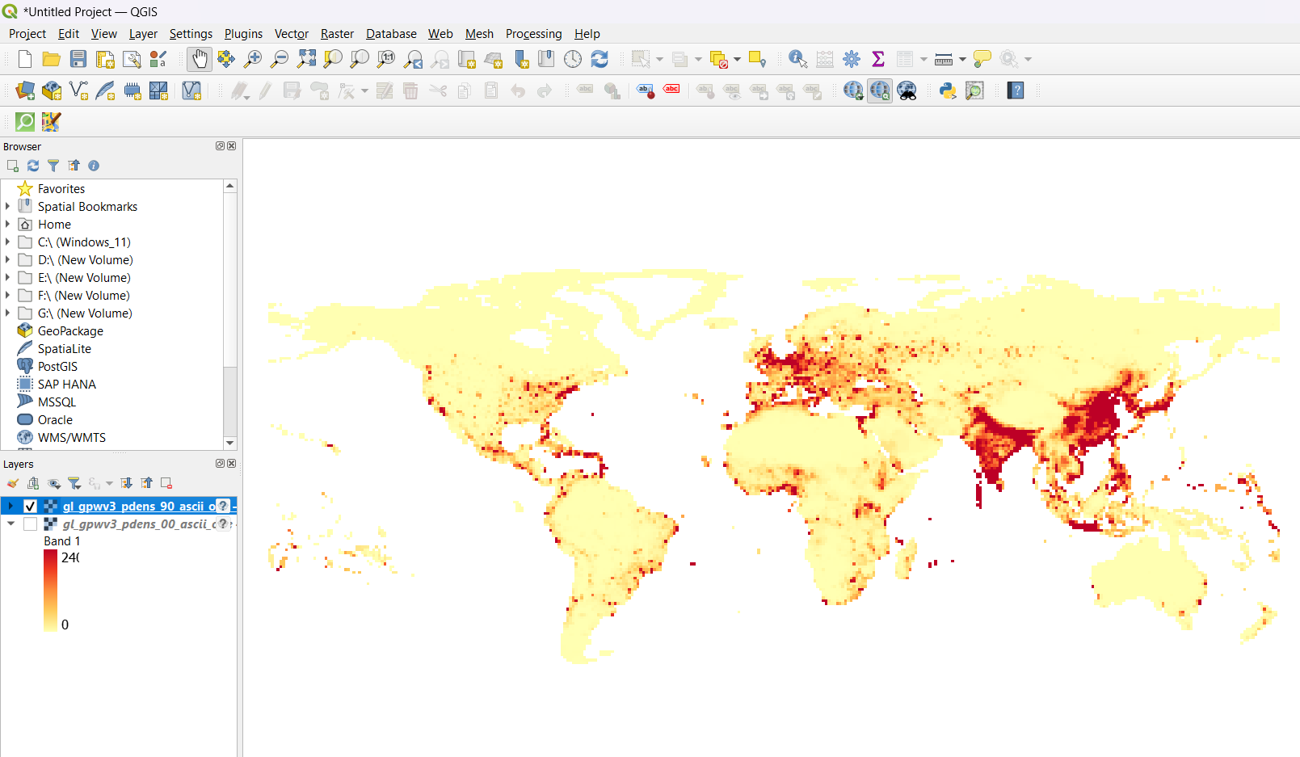

Now Select Raster > Raster Calculator >

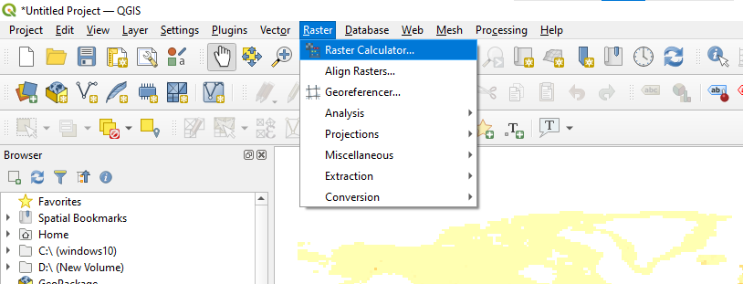

Select gl_gpwv3_pdens_00_ascii_one - gl_gpwv3_pdens_90_ascii_one for Raster Calculator Expression > Browse the location and file name in Output Layer box > Click Ok >

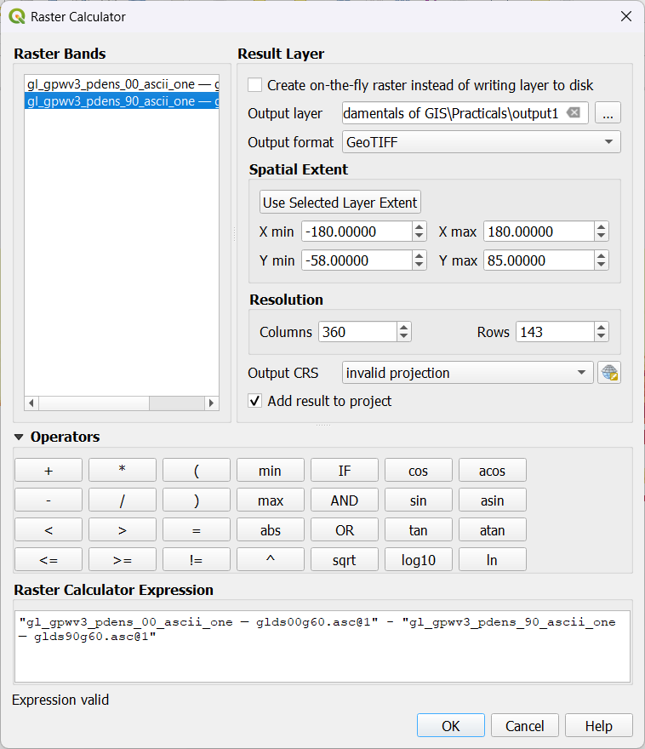

Output after Applying Raster Calculation on two layers >

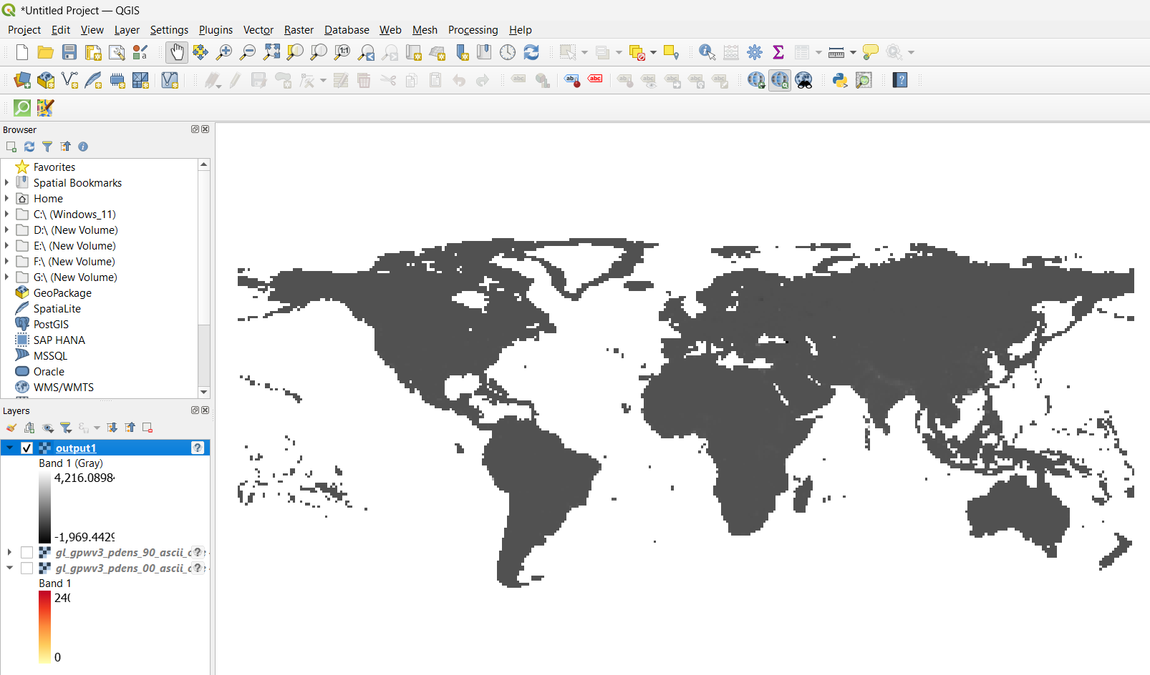

Change the properties of Output layer > Render Type as Singleband pseudocolor > Min : -2000 and Max : 6000 > Interpolation as Discrete > change color classes as below > Apply >

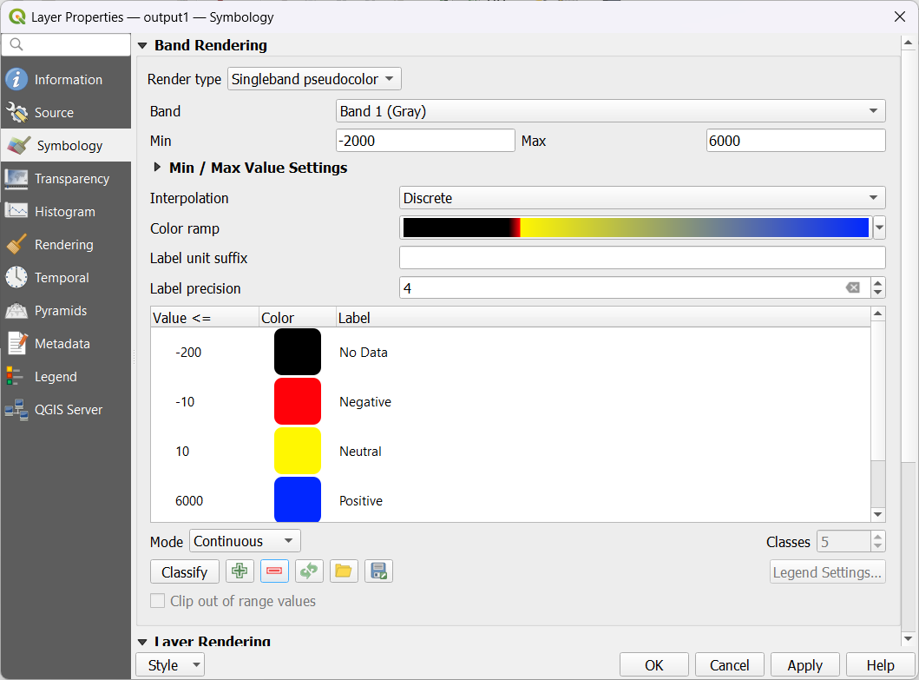

Final Output of Raster Analysis :

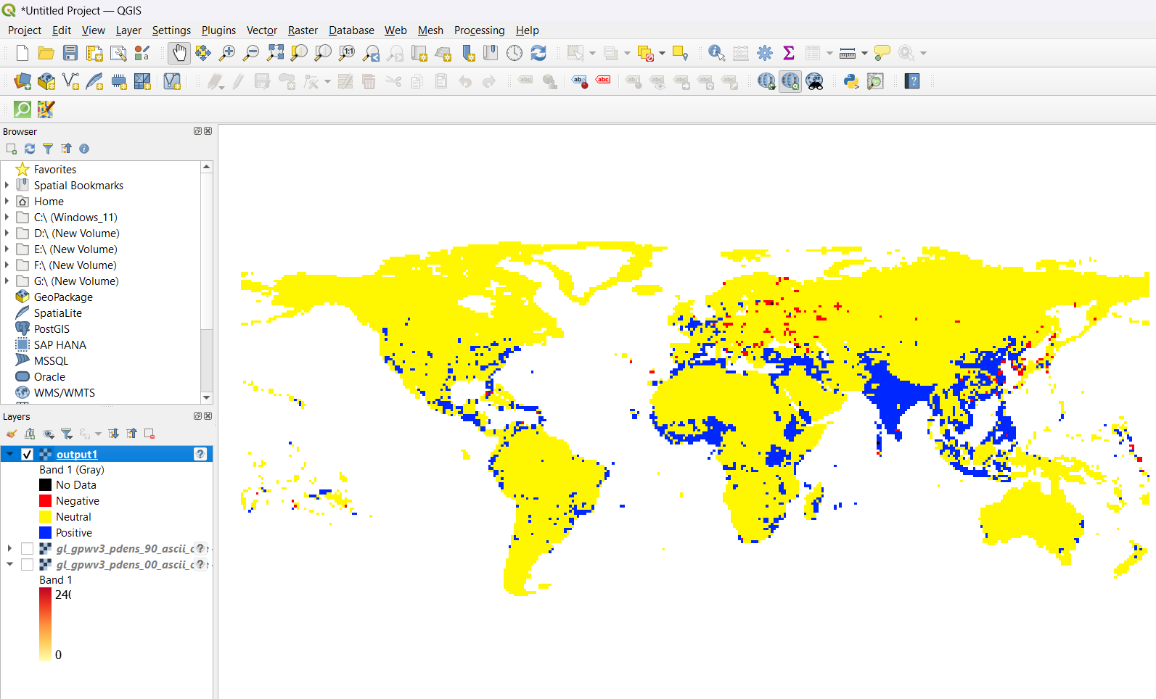

**Raster mosaicking and clipping:**

Layer > Add Layer > Add Raster Layer >

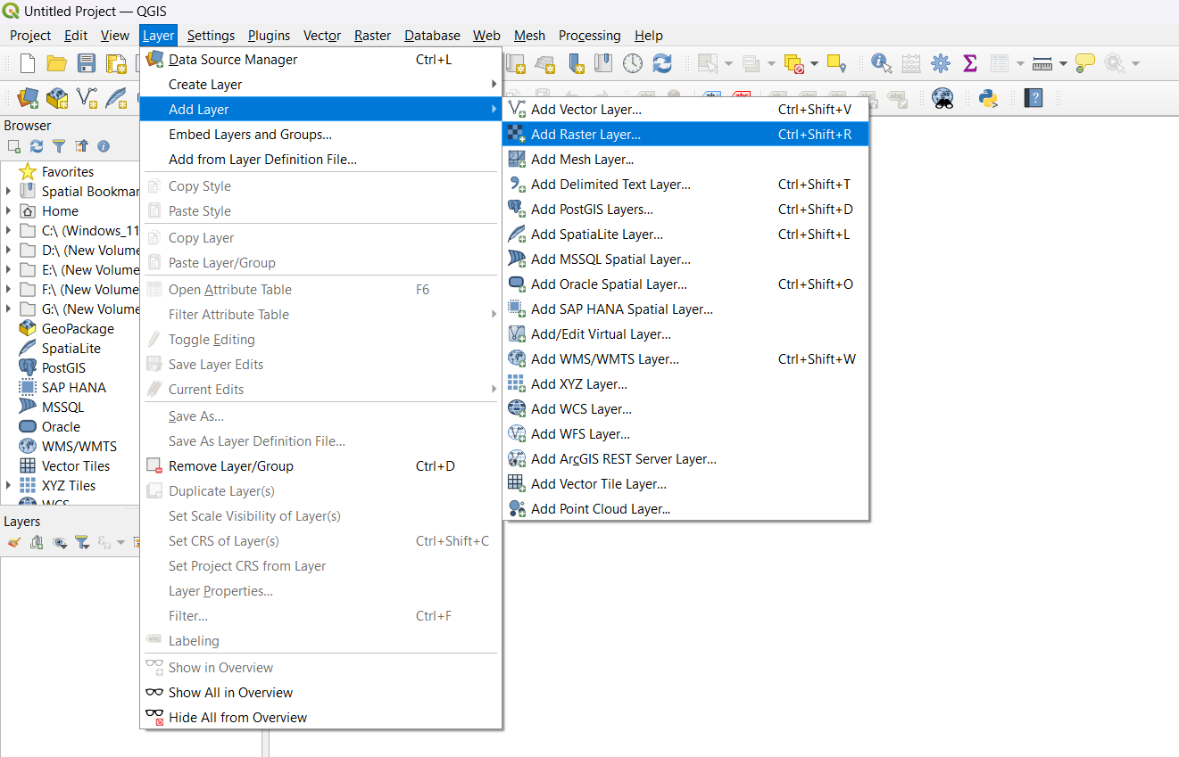

Select all .2km files > Open >

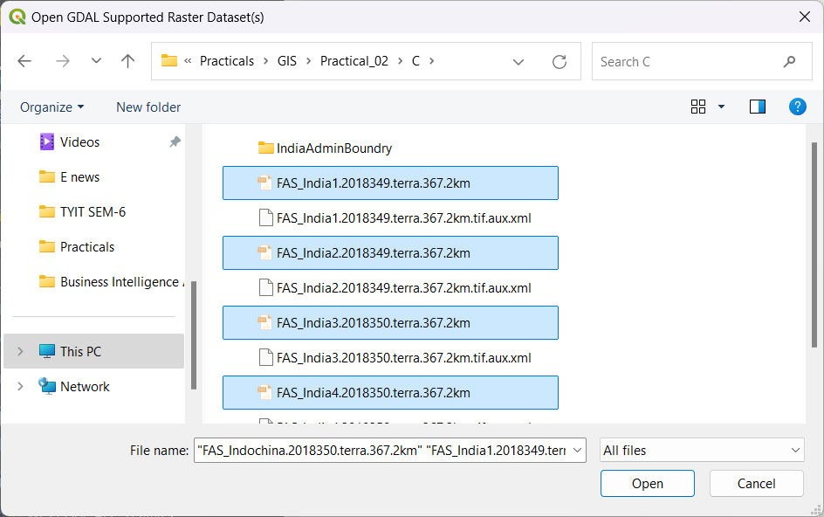

Add the Selected layers >

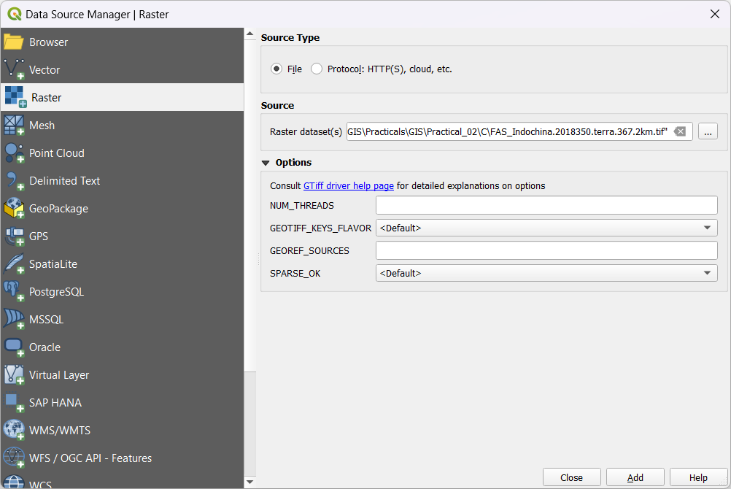

Output of added Layers >

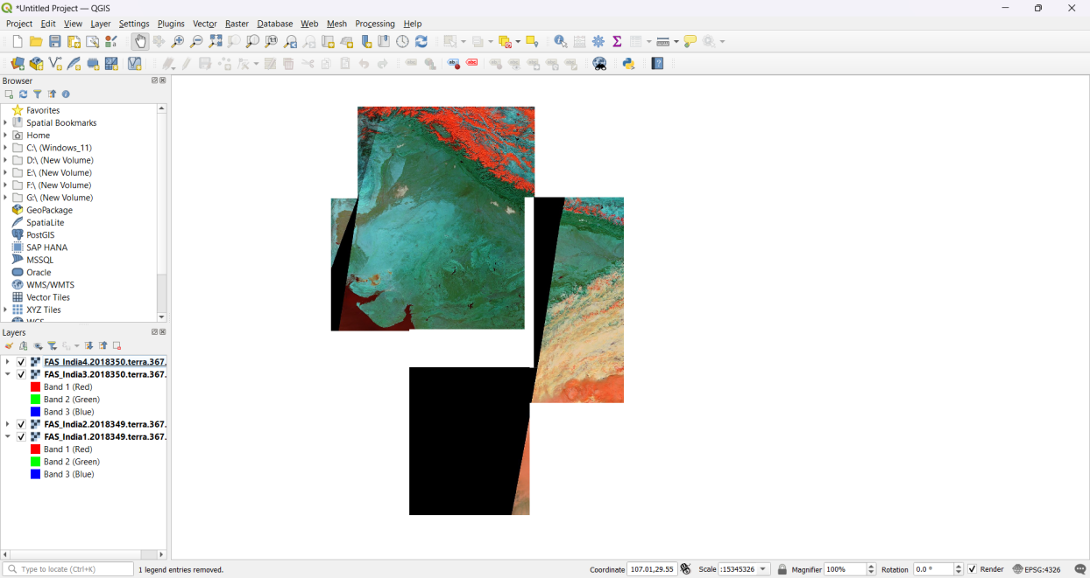

Raster > Miscellaneous > Merge >

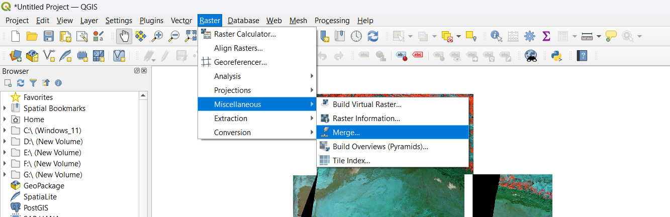

Select All .2km files > Ok >

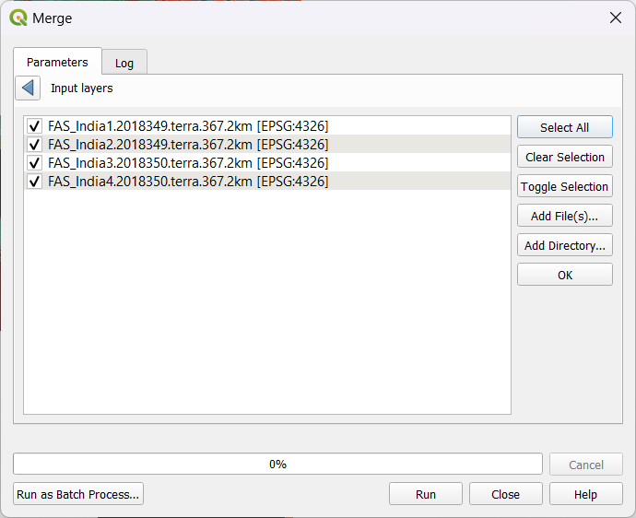

Scroll down and select browse at Merged > Save to File > Run >

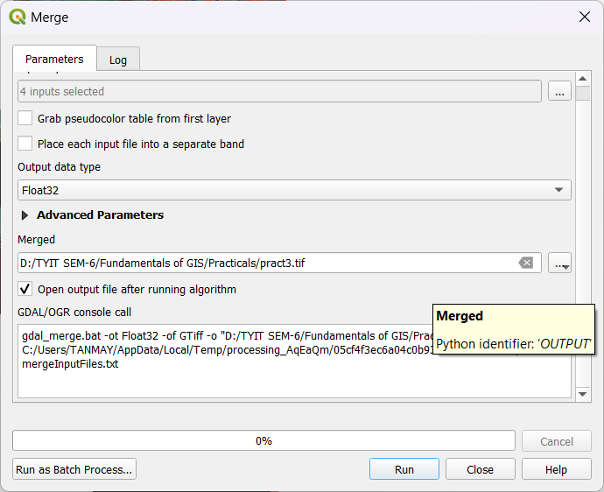

Output After Merging >

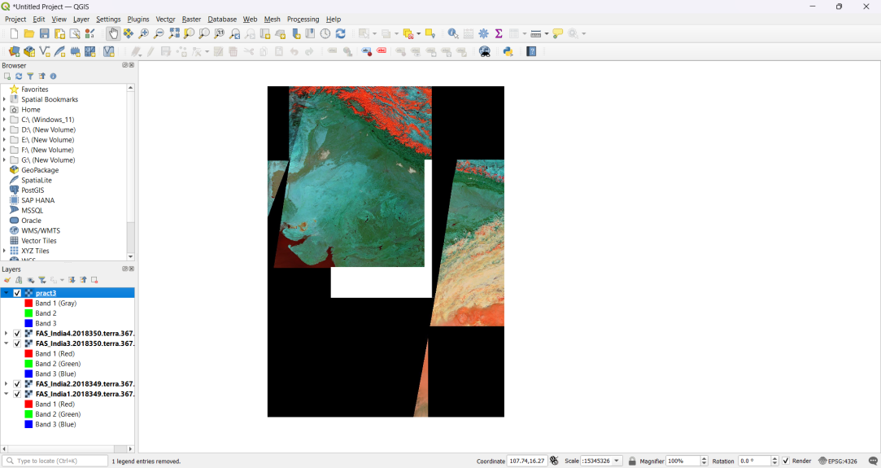

Layer > Add vector layer > Select IND_adm0.shp > Add >

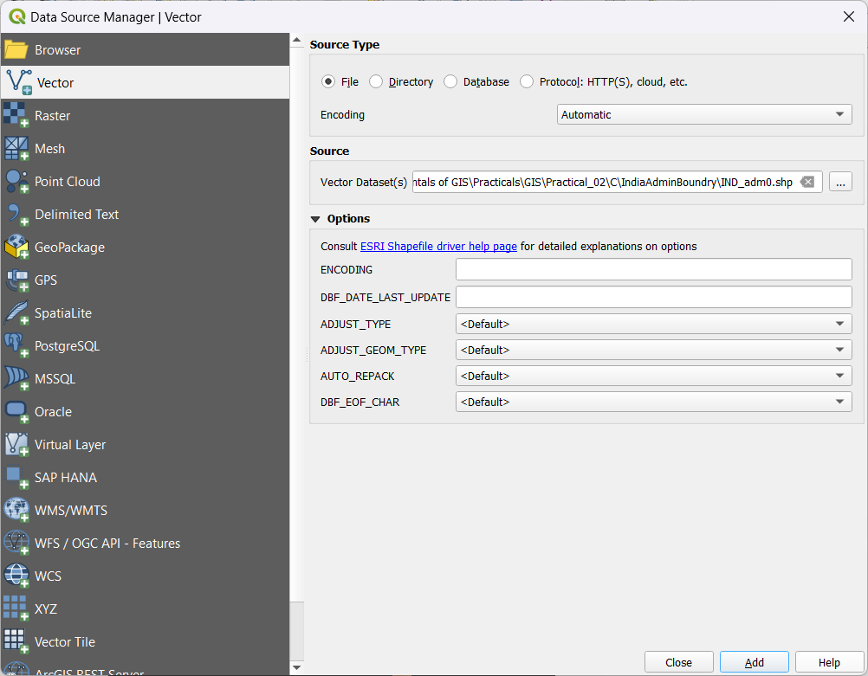

Open Properties > Change Color as Outline blue > Apply >

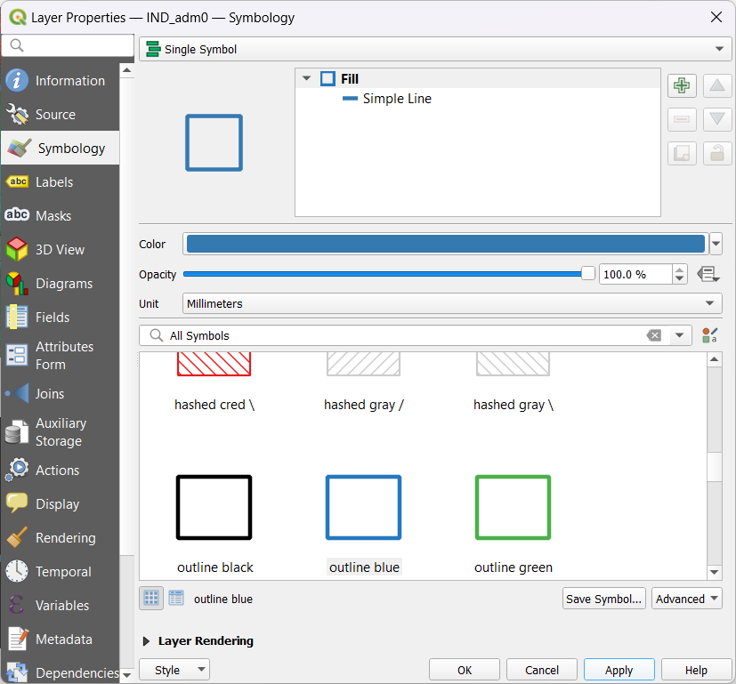

Output After adding IND_adm0 Layer >

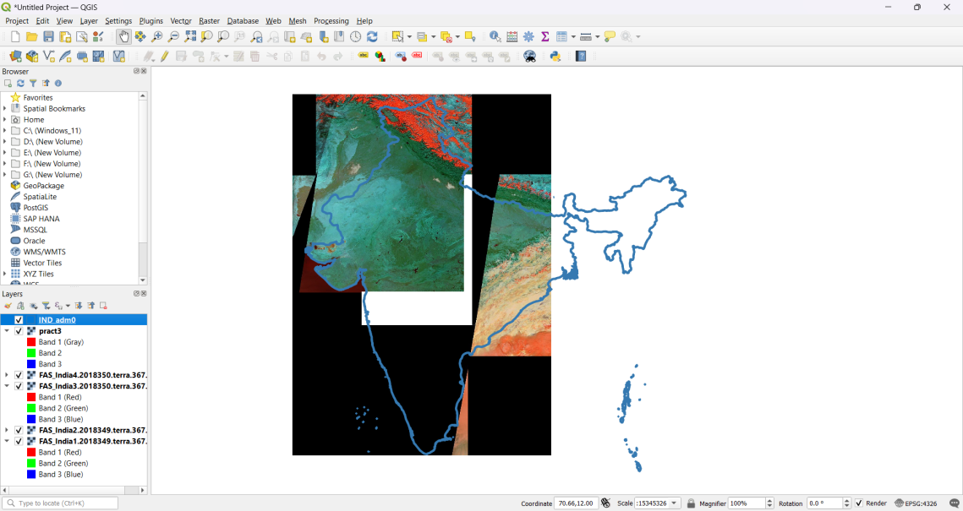

Raster > Extraction > Clip Raster by Mask Layer.. >

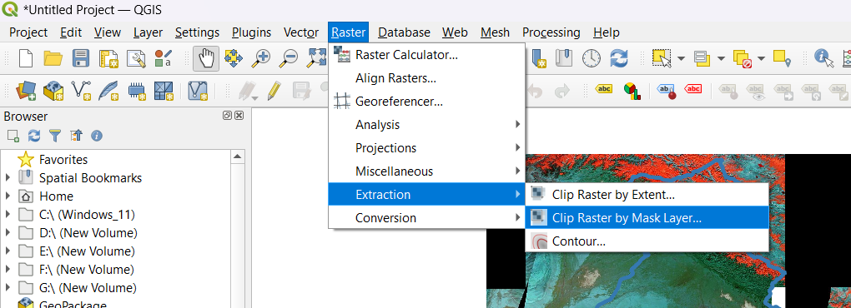

Select Saved Merged Layer > Select Source CRS As WGS 84 > Run >

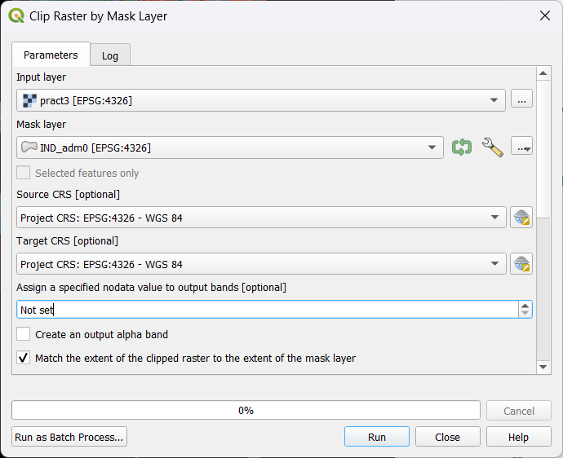

Final Output After Clip raster by Mask Layer >

